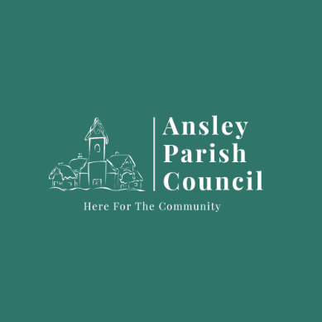
Ansley Youth Group Parent/Guardian Permission Slip
for their Child/Young Person to Attend Youth Group.
 Permitted ages are 11 – 18 (this will be split into suitable age groups).
The Child/Young Person MUST live in Ansley Village , Ansley Common or Birchley Heath (this is budgeted ONLY for Children/Young people who live in the Ansley parish)
1. Name of Young Person: _________________________________________________
2. Sex (Please Tick): Male Female
3. Date of Birth: ________________ Current Age: __________
4. Address: ____________________________________________
____________________________________
____________________________________Post Code: ___________________________
5. Medical Information: (e.g. asthma, epilepsy), diabetes/other Please Specify).
NOTE: If a Young Person requires their inhaler in the day, at school/college, they will need to bring their inhaler to Youth Group. Also, please name the inhaler.
__________________________________________________________________________________________
__________________________________________________________________________________________
6. Special Educational Needs: (e.g. autism, ADHD, behavioural issues). Please specify.
______________________________________________________________________________________
7. Allergy: Is the Young Person allergic to anything? Please specify:
__________________________________________________________________________________________
__________________________________________________________________________________________
8. Photograph Permission for photos to be shared in local news bulletin
Please Tick: YES NO
9. Tick one of the following:
I give permission for my child /Young Person to walk home.
An adult or older sibling will collect my child ? Young Person from the Church Hall at the door (not car park).
10. Any Other Information: (e.g If a parent/other has a Child Protection Order in Place, a Safeguarding Issue) ____________________________________________________________________________________________________________________________________________________________________________________
Signature of Parent/Guardian: ____________________Print Name: ________________________________________
Date: _______________________
If you need help completing this form, please email ansleyparishclerk@gmail.com

With thanks to:
Ansley Youth Group is funded by a grant from Warwickshire County Council. On behalf of Ansley Parish Council, we thank them for supporting Youth provision in our parish.

